

PRESS RELEASE CONTACT: Sandra Grabman
(580) 252-3547
FOR IMMEDIATE RELEASE books@benohmart.com
July 28, 2026 www.bearmanormedia.com

An Elusive Oscar

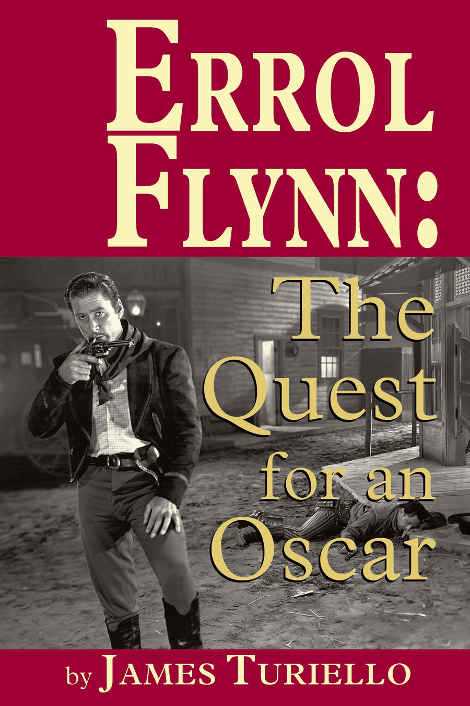
Albany, GA – BearManor Media proudly announces the release of its new book, Errol Flynn: The Quest for an Oscar.

Men wanted to be him, women wanted to be with him. Errol on the other hand, wasn¹t particularly interested in acting. He was a free spirit who played by his own rules, much to the chagrin of the Hollywood producers. He was up for any role and would play it so convincingly that it transported the viewer into another world—from the most loved man-of-the-people, Robin Hood, to the most audacious pirate in The Seahawk, to the bravest soldier as General Custer. Inside this volume are over 200 photographs of Errol Flynn in his many movie roles, as well as candid images, most never before published. There are rare artwork posters from around the world, and some unique Errol Flynn items depicted. This book includes Errol Flynn¹s complete filmography with a short synopsis of each movie, including the entire cast. Whether you are familiar with Errol Flynn and his body of work, or a newcomer, this book will definitely give you an insight into all the different aspects of his career in the movies.

To learn about this or other BearManor Media titles, please visit our website at www.bearmanormedia.com.

ISBN: 978-1-59393-695-2
Format: Softcover; 6” x 9”; 265 pages
Price: $19.95
Available through Ingram and amazon.com

About the author
Jim Turiello grew up in Washington Heights, New York, where he went to the many movie palaces in his neighborhood, as well as those at Times Square. As a prolific writer his contributions to music, movie and collectable magazines are too numerous to mention. He loves to travel and has been to most Caribbean islands.

About BearManor Media
BearManor Media is a small press that publishes BIG books. They pride themselves on publishing quality entertainment biographies, so they often put out the first book on unique subjects. BearManor Media specializes in books with nostalgic themes like George Raft: The Man Who Would Be Bogart; Don Ameche: The Kenosha Comback Kid; Plain Beautiful: The Life of Peggy Ann Garner, and Fess Parker: TV’s Frontier Hero.

